City of Lincoln Garbage and Recycle Tote Placement
The City of Lincoln and TrashTrash ask for your help in placing the totes properly within the City to ensure a smooth garbage pick up. This is also to help the City maintenance staff to maintain the streets as needed as well.
- Totes must be set out by 6:00 a.m. on your scheduled pickup day to ensure pickup
- Totes must be placed at the end of the driveway OFF the street or boulevard
- Totes should have the wheels and handles towards the house
- Totes must be at least 3 feet apart and clear of any objects; such as cars, campers, mailboxes, etc.
- Handle faces house
- Front faces street
- Tote behind curb
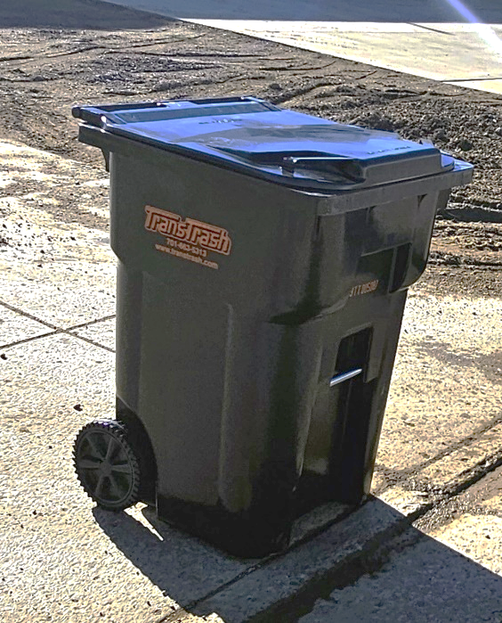
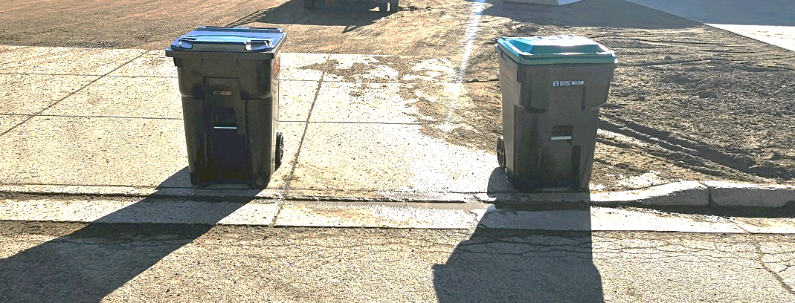
Any questions on this, please call the City (258-7969) or TransTrash (663-5313). Thank you.
At least 3 feet apart

